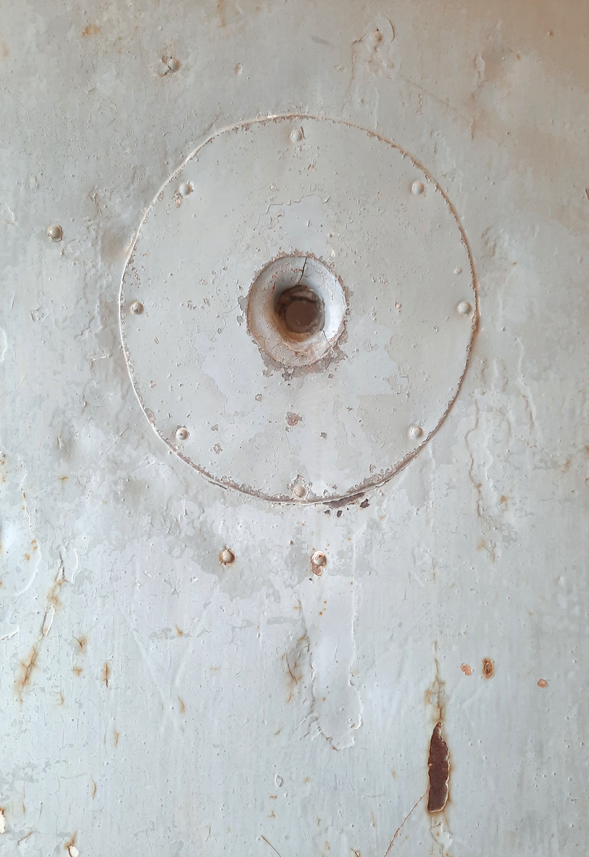
The Judas Window:
A Production Diary

Paul Bamlett - Producer & Director

Paul Bamlett is an experienced director, actor and theatre administrator with over forty years of experience in theatre and associated professions.
Beginning in 1980 as an actor with Snap Theatre Company, Paul has worked using drama to support people in prisons, drug and alcohol rehabilitation and people with learning disabilities. He is a qualified drama therapist and has worked in numerous schools using his skills to enable students who find school difficult.
Paul has directed numerous productions including The Cherry Orchard , The Homecoming, Blood Brothers and The Tempest and has acted in others including Country Dancing and Measure for Measure to name a few.
From 2004 until 2014 Paul created and ran his own inclusive touring theatre company Actability, which in addition to creating their own touring productions and providing creative opportunities for people with a variety of abilities also worked in dozens of mainstream and special scholars in the UK and in Bulgaria and Poland.
Now in a unique new partnership with PS Lynch, Paul Bamlett is bringing his experience and skills to bring a new, innovative and exciting theatre piece The Judas Window to the stage in collaboration with a superb team of creative professionals.

So, the die is cast! After months of debate, research , interviews and auditions we have reached a decision to make Through a Judas Window a one man show.
Since reading PS Lynch's incredible novel A Mind Prone to Evil some 18 months ago we ( myself and PS Lynch)have been on an on incredible journey. I suggested that it would make a superb stage show.
Within a matter of days Paul, (yes there are 2 of us) had turned his novel into a magnificent piece of theatre.
We held auditions, and spoke with some fantastic, talented people. Quickly we came to the conclusion that it would not be easy to raise the necessary money to make this happen and the story of Hermann Göring is hardly loaded with inclusivity and diversity options which would make us eligible for Arts Council funding.
Long story short.. we went to Nuremberg where after spending time in the courtroom where the trials actually happened. The revelation came to us that we could do this as a one man show, cutting our costs and creating something very special at the same time.
With great enthusiasm i delved into how a one man show might work. My previous work was either directing or appearing in big ensemble pieces or devising with smaller casts so I needed to consult the masters of the craft. David Hare, Antony Sher and Andrew Scott have been consulted, albeit in book form.
The script has been tightened and sculpted, the stage and lighting cues worked on , the theatre is booked.... let the games begin....to be continued.

